Editing your education-related faculty development activities in Re-AIMS
Log into “RE-AIMS.”
- To edit existing courses and notate them as education-related, select the section you want to update. (Teaching and Education-related fields are found in the following sections: Courses Attended, Presentations, Bibliography, Professional Memberships, and Institutional Committee memberships).
- Click on the “Actions” button and “edit” existing education related activities in REAIMS
- Note: The only sections that will show up in your REAIMS Report are the educational activities that are in the following sections: Courses Attended, Presentations, Bibliography, Professional Memberships, and Institutional Committee memberships). If you select “option 1” for your application for the Academy of Educational Excellence, the REAIMS report is what the committee will reference for your education skill development hours (criteria 1).
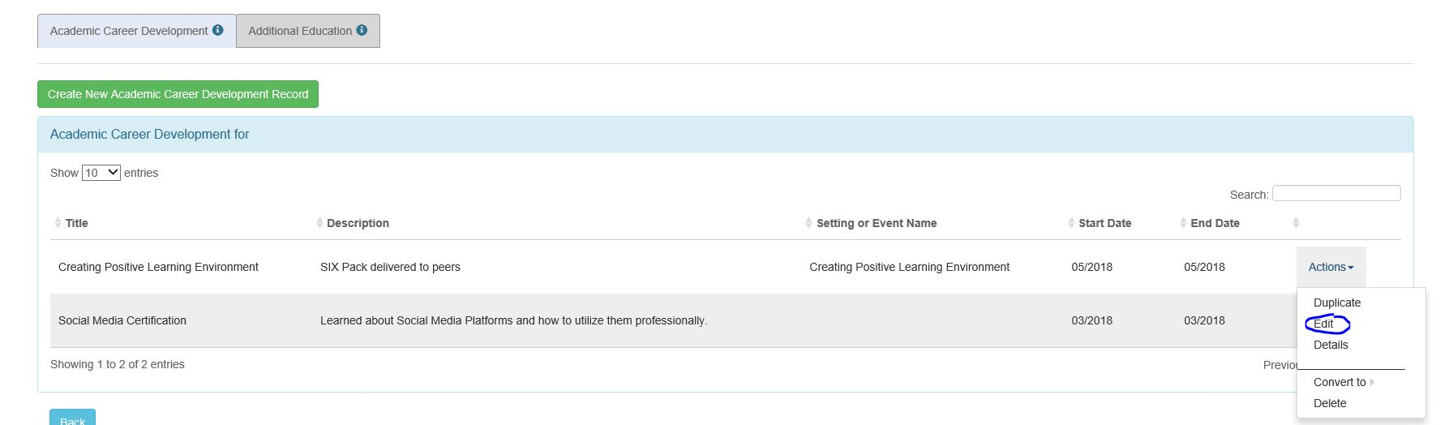

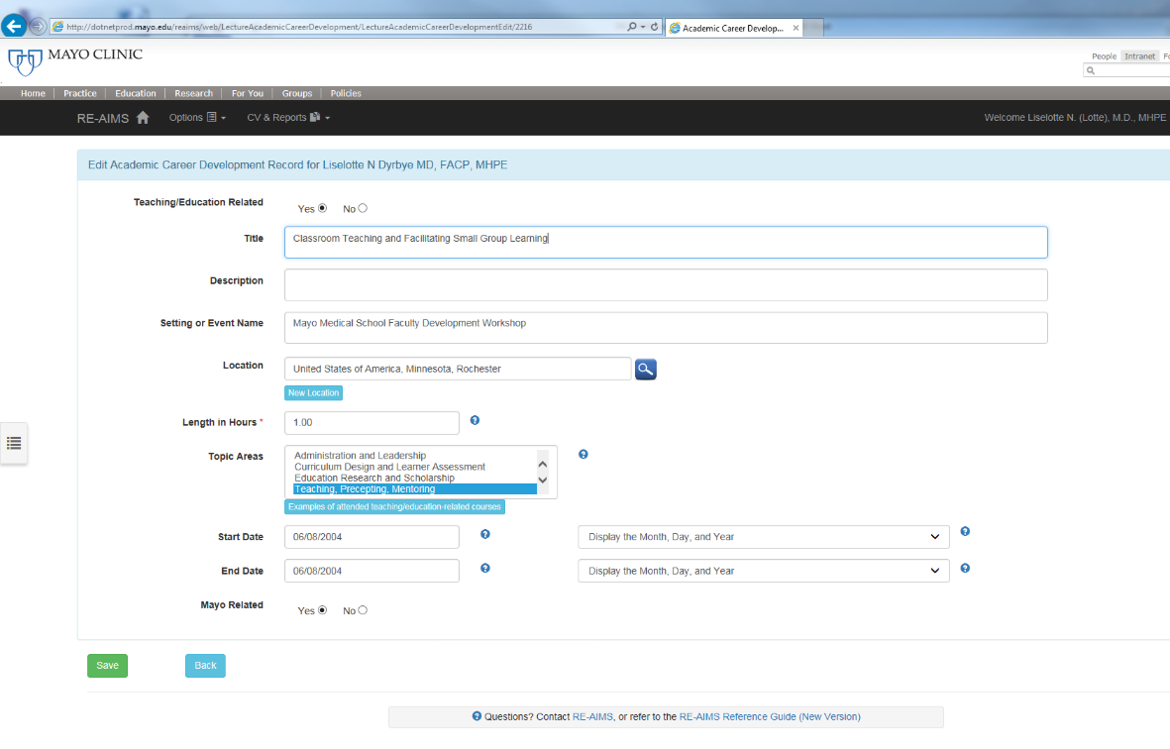
Change “Teaching/Education Related” field to “yes” if the activity is related to education, input the length of hours this activity was related to and press “save”. Doing this to all of your education-related activities will allow for a report to be run within RE-AIMS. Note: If you do not select yes on each activity, they will not show up when you run your RE-AIMS report.

Documenting education-related faculty development in Re-AIMS
Go to “Courses Attended”
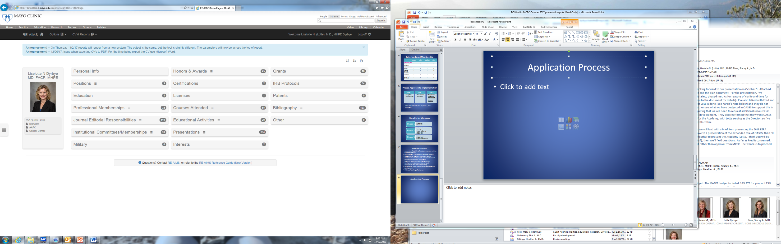
Click on “Create New Academic Career Development Record” to create a new academic career development record or open prior ones. Indicate session was related to teaching/education by selecting “yes”, length of session (hours), and topic area. Hit save. These three areas are vital for it to show up on your REAIMS Report.

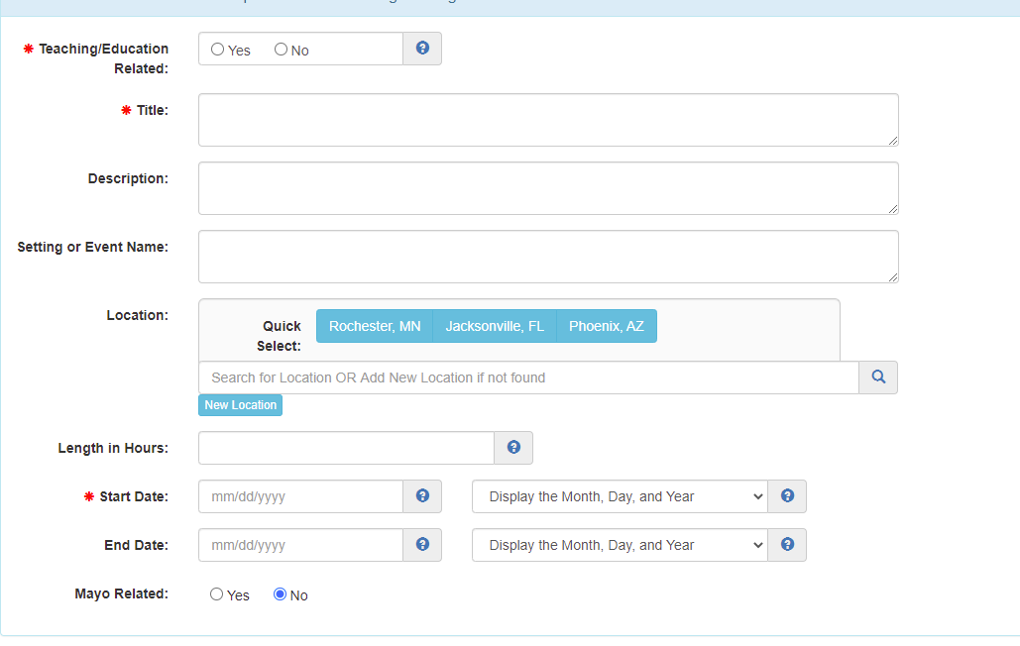

Documenting education-related presentations and publications in Re-AIMS
Go to “”Presentations” or “Bibliography”
Create a new presentation/publication record or open prior ones. Indicate session was related to teaching/education by selecting “yes”. Note that the default is on “No”. Hit save.

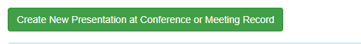
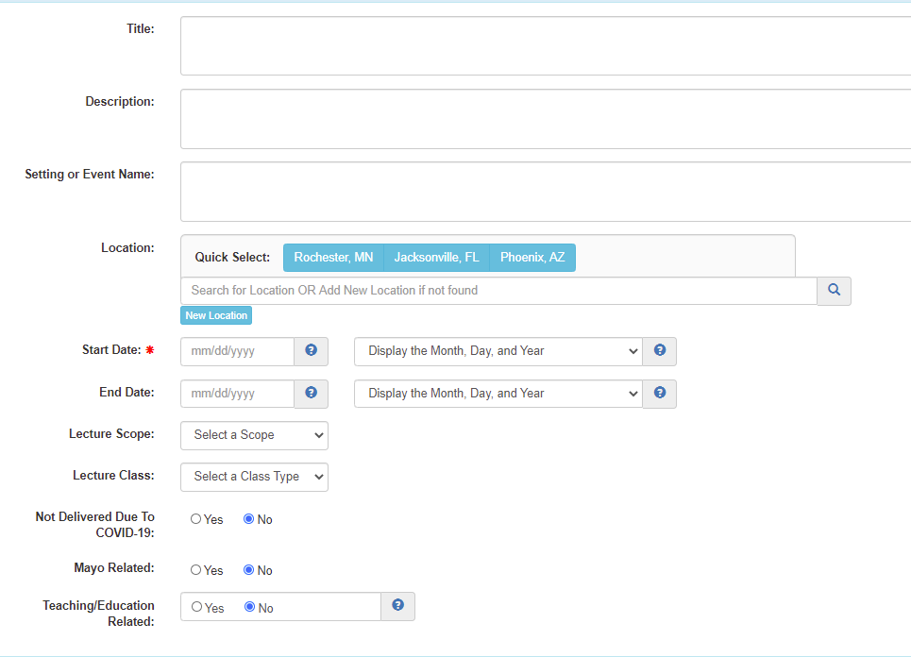

Documenting education-related professional society and committee roles
Go to “”Professional Memberships” or “Institutional Committee Memberships”
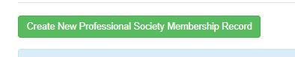

Create a new professional society or Mayo/Non-Mayo committee membership record or open prior ones. Indicate session was related to teaching/education by selecting “yes”. Note that the default is on “No”. Hit save.

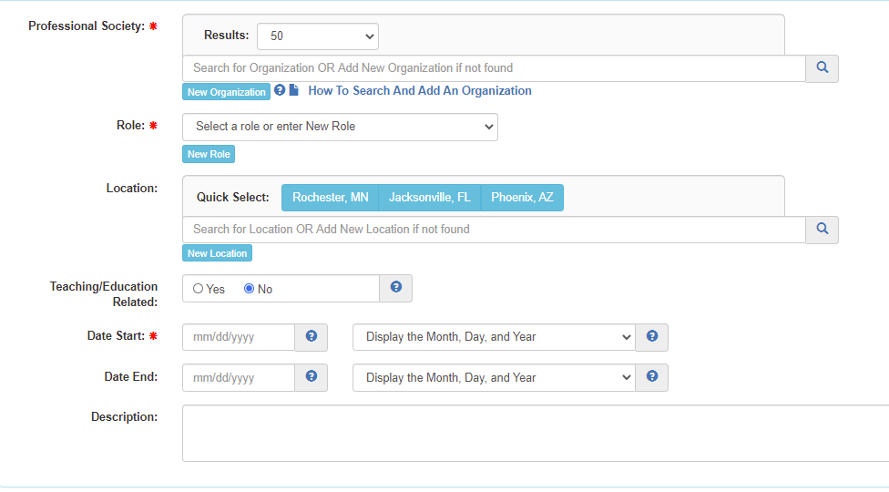
Run a report of education – related activities and outcomes in REAIMS
Access report here
https://biprodssrs.mayo.edu/Reports/Pages/Report.aspx?ItemPath=%2fRE-AIMS%2fStandardReport%2fEducationRelated&ViewMode=Detail
1. Indicate Begin Date and End Date
2. Default is All Categories – probably best to leave as is
3. Leave Teaching Related Flag as True
4. Provide Lan ID
5. Click View Report
55
1

2
3
4

6. The report should look like this (screen shot). Note: If nothing appears in the report, you have not clicked “yes” to any teaching/education related activities and you should refer to the beginning of this document to complete this step before running your report.
Click on the save button (located below the “teaching related flag) and save as PDF to your file.
